Constant position variable gain for dancer positioning

Owen Lu

Electroimpact Inc.

owenl@electroimpact.com

*Abstract*—This document describes a non-linear control method based on a proportional control scheme to efficiently use the dancer stroke during multiple payout scenarios. Currently, the control technique is based on using motor specifications to calculate the highest gain possible for a proportional controller. This creates unnecessarily large torques during material adds. Furthermore, with a changed specification to ramp speeds up to 6000in/min, dancer stroke reduction is of great importance. This variable gain method is designed to reduce torque peaks and dancer stroke.

# Introduction

From simulation for the two conditions the two conditions were tested, a step velocity input at 2000in/min simulating an add. And a ramp to 6000in/min at 0.5G. It was found that the 2000in/min tests requires a much larger peak torque. However, if the gain is set too low, large speeds will cause dancer over travel. Thus, this method was develop to use the servo motor more efficiently, allowing larger stroke at lower speeds, and reducing stroke at higher speeds.

# Original control loop

The original simulated control loop assumes a perfectly integrating plant, which makes the assumption that position commands are generated perfectly from the inner control loop. Details are discussed in “Preliminary spool motor sizing and high level controller design”. The original control loop has been shown to work in practice as long as the gain is selected such that the maximum torque requirements are lower than the specification max.

# Steady state displacement

From the original control loop, given the payout velocity and the gain, the steady state dancer position can be calculated.

|  |  |  |
| --- | --- | --- |
|  | $$x_{ss}=\frac{v}{K_{p}r_{s}}$$ | (1) |

For simplicity, we define $K_{p}r_{s}$ to be the effective gain $K_{e}$. This gain is multiplied to the error to generate an output velocity at the gearbox flange.

|  |  |  |
| --- | --- | --- |
|  | $$K_{e}=K_{p}r_{s}$$ | (2) |

Thus, a desired steady state dancer displacement and knowing the tow velocity, the gain can be calculated and is valid for non-zero velocities.

|  |  |  |
| --- | --- | --- |
|  | $$K_{e}=\frac{v}{x_{ss}}$$ | (3) |

# Time constant variability

The main problem with defining the gain purely based on the payout speed is that the gain is low for low speeds. This means that the response of the system is very slow when the machine is moving slow. Another issue, is that since the gain is zero during times where the machine is not paying out, there is tension loss in the system as the controller will not attempt to restore tension.

The time constant for the dancer travel control loop can be calculated below.

|  |  |  |
| --- | --- | --- |
|  |  | () |

# Gain limit

Since the gain is variable during payout, it is important to generate hard limits on the maximum to ensure no over current occurs in the motor. A conservative estimate of the maximum gain is shown below, assuming a step input of $v$ with $I_{e}$ as the output inertia of the spool system.

|  |  |  |
| --- | --- | --- |
|  |  | () |

Assuming that the SM34165DT is being used with a 8:1 reducer, then $T_{m}=28Nm$.

Assume that material adds are done at 2000in/min, with a 8.5’’ diameter spool.

|  |  |  |
| --- | --- | --- |
|  |  | () |
|  |  | () |
|  |  | () |
|  |  | () |

# Controller switching conditions

Supposing that we use the maximum gain calculated in (9) then the steady state displacement can also be calculated for a 2000in/min payout. This is done in (10) below.

|  |  |  |
| --- | --- | --- |
|  |  | () |

Currently the dancer stroke in our system allows for a maximum of 3 inches of travel. We can see we do not even use 1/10 of the stroke if the gain were turned up to maximum.

Using the same maximum gain, the same calculation can be done for 6000in/min payout.

|  |  |  |
| --- | --- | --- |
|  |  | () |

Thus, in the above scenario, theoretically any stroke larger than 0.706in is sufficient. To build some safety margin we simply assume that a max travel of 1 inch is acceptable.

Since acceleration of tow velocity happens between 2000in/min and 6000in/min let us calculate the gain corresponding to steady state dancer travel of $x_{ss}=0.75in$.

In the 2000in/min case

|  |  |  |
| --- | --- | --- |
|  |  | () |

In the 6000in/min case

|  |  |  |
| --- | --- | --- |
|  |  | () |

We can see that in all such cases, the gain is lower than the maximum gain calculated in the worst case scenario, allowing for safe operation.

Therefore, in order to develop a control technique, we set a lower saturation limit of the $K_{e}$ to be $44.44rads^{-1}$ and the upper limit to be $K_{e}=133.33rads^{-1}$ and switch on the boundary $2000in/min$.

A simulation was conducted with the following tow velocity profile shown in Figure 1:

1. Step to 2000in/min
2. 0.5G ramp up to 6000in/min
3. 0.5G ramp down to 1600in/min
4. Step down to complete stop

We can see that the simulation shows no significant dancer travel after the first ramp. Since 2000in/min is the threshold for gain switching, the dancer lowers is position as 1600in/min is reached. In the final phase it comes to a complete stop simulating a clamp operation.

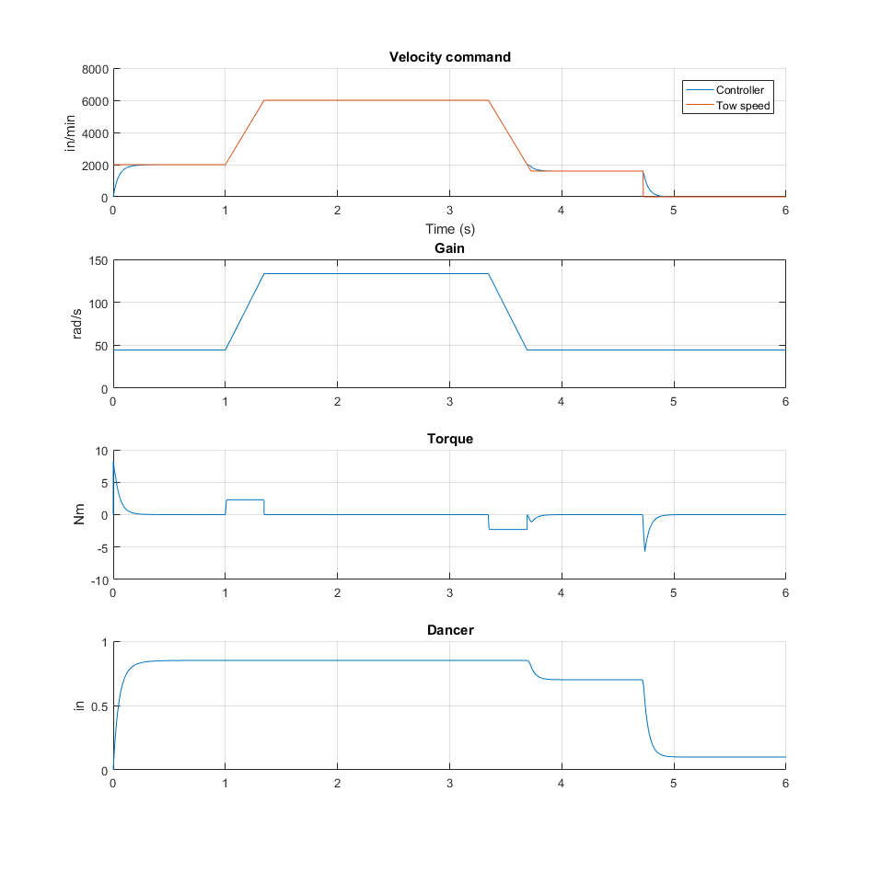

Figure – Proportional vs. Constant Position Gain methods

# Conclusion and further study

This paper shows that it is possible to choose the gain of the system in a fashion that allows for efficient use of the dancer stroke. However, this paper only investigates the scenario where the tow velocity is known. Therefore, in practice, the velocity, which is sent over a digital protocol must be received via interrupt based methods and synchronized with the actual control loop of the motor. This is undesirable since it adds complexity to the implementation and possible failure modes if the master PLC is unable to report the correct velocity. Further study will be conducted on gain selection methods based on pure feedback techniques. This will likely complicate the control loop, but eliminate the need for velocity feed forward.